A service principal is an identity created for use with applications, hosted services, and automated tools to access Azure resources. This identity is used to authenticate and gain access to resources in Azure Active Directory (Azure AD). Service principals are particularly useful for scenarios where an application or service needs to authenticate and perform actions without user intervention.

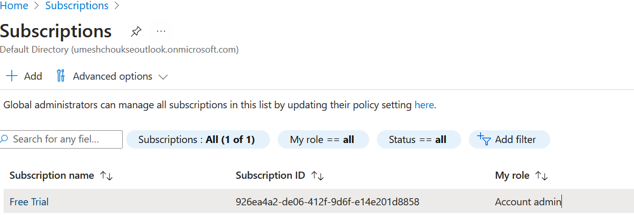

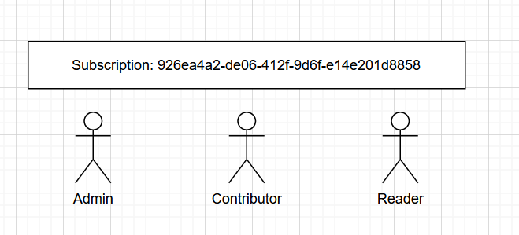

In the subscription, we can have 3 roles:

1. Admin: **full access to manage all resources in the subscription + Admin task**
2. Reader: Who can just read things
3. Contributor: **full access to manage all resources in the subscription**

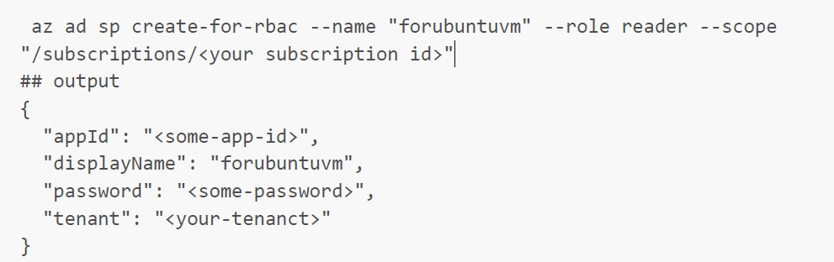

az ad sp create-for-rbac --name <service-principal-name> --role Contributor --scopes /subscriptions/<subscription-id>

az ad sp create-for-rbac --name devserviceprincipal --role Contributor --scopes /subscriptions/926ea4a2-de06-412f-9d6f-e14e201d8858

